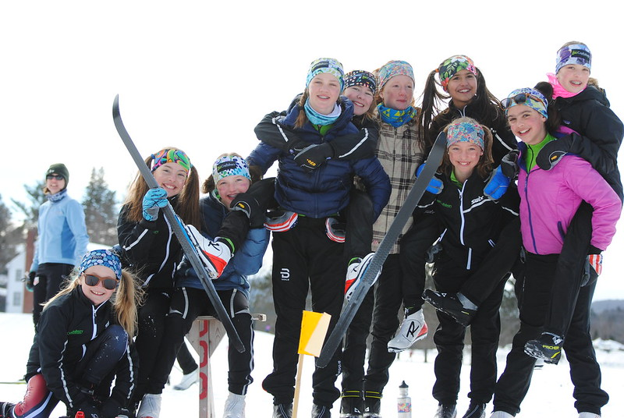  - Sunday, January 26  Photo: Dave Priganc  Lost Nation Super BKL Classic  DOR Registration opens at 11:30 AM.  Grades 7/8 kick-off the races at 1:00 PM.  NO ENTRY FEES  PLEASE NOTE: No fluoro glide waxes permitted at COC-sanctioned events. To learn more about Craftsbury’s wax policy, visit here.  We ask athletes, coaches, and parents to honor our efforts to protect our environment and community. | ____  Classic Mass Start for lollipop through grade 8!  ____  Cookies! Cookies! Cookies!  ____  Ribbons in many colors!  ____  Glitter Encouraged!  Craftsbury Outdoor Center  Craftsbury, VT

